Exhibition Space Application

The Jiangsu Industrial Technology Research Institute (JITRI) is building a new long-term exhibition hall in its new Headquarters Innovation Campus, featuring 15000m² of the most recent scientific and technological achievements from around the world, and highlighting technology trends for the next five years. The Jiangsu International Technology Exhibition typically receives visitors, press and TV coverage daily, including from organizations interested in international cooperation, high-level government, embassies, consulates, investors and trade missions.
The WAITRO Secretariat, China Office, is providing free space for WAITRO members to highlight their technology achievements and success stories. The WAITRO exhibition will be a special section with many potential benefits for WAITRO members:
- Display your research interests, technology, market demands, etc. to thought leaders, investors and experts not just from all over China but from around the world.
- Find potential collaboration partners.
- Press and TV coverage.
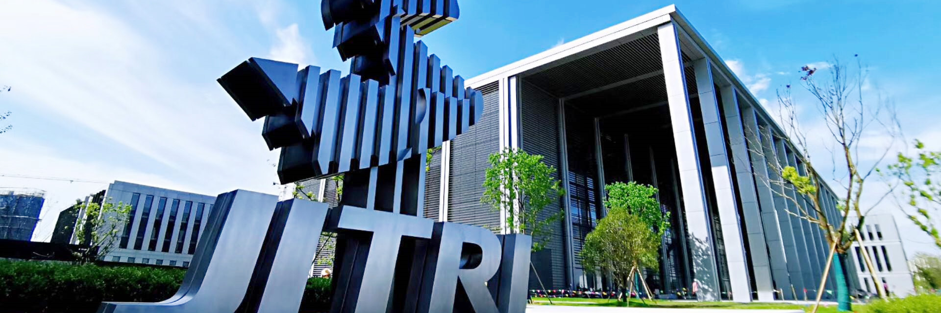
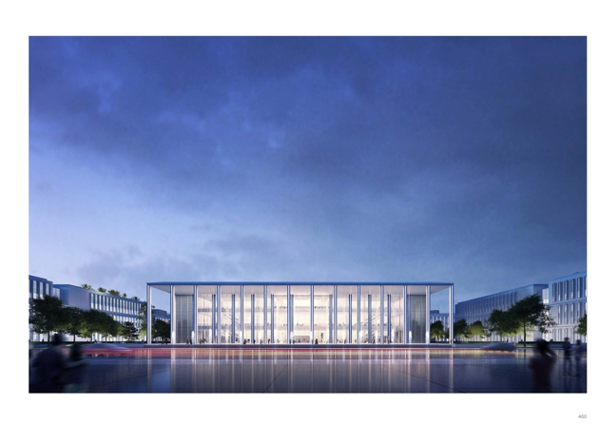
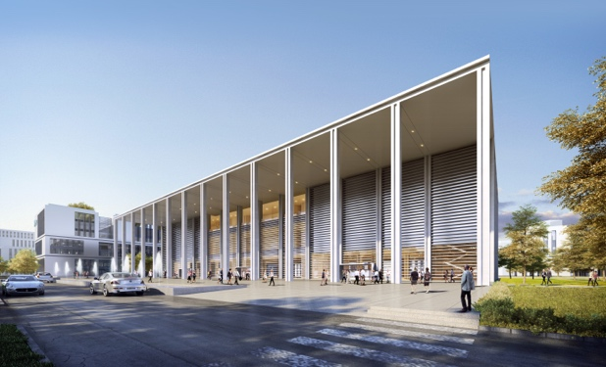
We hope the WAITRO exhibition will be a bridge between you and the global technology market. Full and Associate Members are welcome to apply for exhibits featuring posters (introduction to your organization, cooperation highlights, research priorities, etc.) demonstrations or models, video, virtual reality presentations, etc. As an introductory offer, any necessary shipping or transfer fees will be covered by the WAITRO Office, China, for members who apply by May 31st 2021!
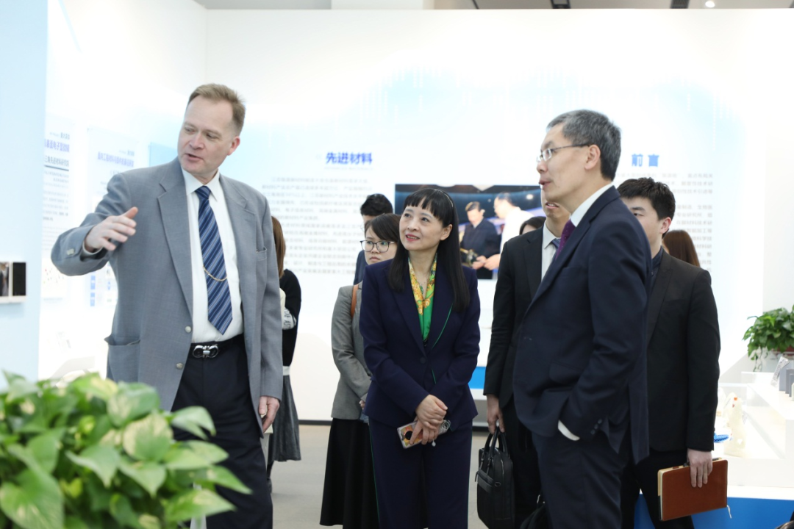
JITRI Vice President and Head of the WAITRO Office, China, Dr. Paul Burrows, explains the Exhibition to the Ambassador of Singapore to China, His Excellency Mr. Lu Deyao
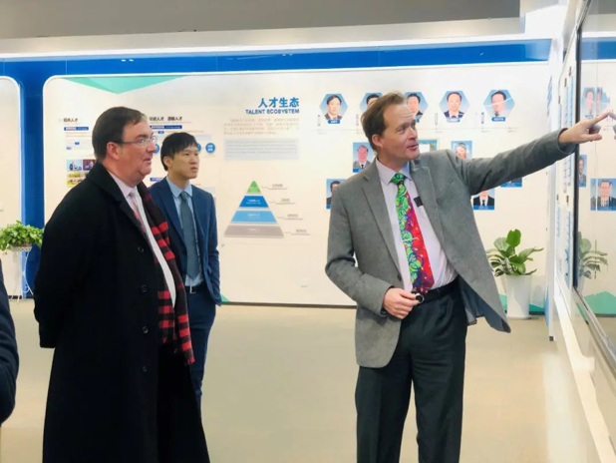
JITRI Vice President and Head of the WITRO Office, China, Dr. Paul Burrows, explains the Exhibition to Chris Wood, Consul General of the British Consulate in Shanghai.
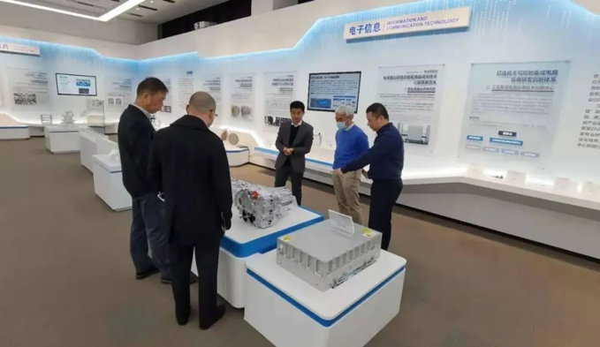

Mr. EGAWA TAKESHI, Director and Deputy General Manager of Mitsubishi Electric (China) Co., Ltd. and Deputy Director of the International Intelligent Manufacturing Alliance (Preparatory) Industry Committee visit JITRI exhibition hall.

Application Form for Exhibition Space in WAITRO Office, China

Name of organization |  | Country
Official website
Address
Contact person
Phone |  | Email
Please describe your exhibition items below
- Title of Exhibit:

- Please describe the exhibit that you would like to show.

- What are the dimensions?

- How will it be transferred (shipment, email or other ways)?

- When will it be ready?

- Please describe any necessary conditions for shipment.

- Please show photographs, screen captures, etc. below:

- Title of Exhibit:
……
Please attach any necessary figures or explanations.

